Press release
Paris, september 21st 2020

Within the scope of the revival of post Covid-19 tourism,
Geneva Tourism & Conventions Foundation entrusts its press and influence relations to Interface Tourism France

The leading communication agency specializing in the tourism sector Interface Tourism France has been selected by the Geneva Tourism & Conventions Foundation to manage its public relations & influence in France.

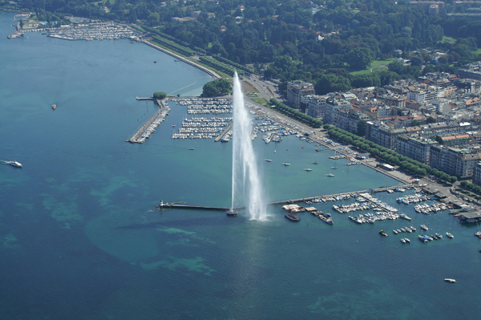  © Geneva Tourisme | 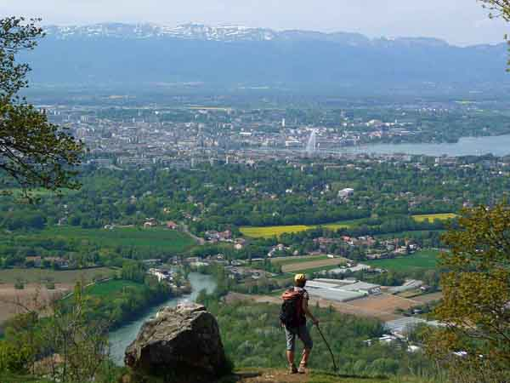  © Geneva Tourisme
Geneva Tourism & Conventions Foundation, has chosen to entrust its press and influence relations to Interface Tourism as part of an exceptional mandate aimed at reviving post-Covid-19 tourism. The communications agency has been in charge of its promotional activities since August 2020.

Close to large French cities, but far from their hustle and bustle, Geneva and its region combine urban pleasures and getaways into the countryside. With a green environment as close as possible to nature, the destination fits in perfectly with new travel trends for travelers looking for tranquility and a change of pace. The Swiss metropolis also seduces with its heritage, its hotel offer, its Alpine landscapes and its wine-growing hinterland.

Blaise Borezée, General Manager of Interface Tourism, is delighted with this new collaboration : “In the current context, we are delighted to be able to support and bring our know-how to Geneva Tourism & Conventions Foundation in terms of press and public relations and influence. We are enthusiastic about the idea of ​​participating in the revival of tourism in Geneva and further revealing its appeal to leisure travelers. We are convinced of the potential of the destination, a multi-faceted city, both cultural, artistic and gastronomic, also giving pride of place to nature in the heart of the city center.”

About Interface Tourism
Interface Tourism is a communications, PR, social media and marketing agency working exclusively in the travel sector.
From offices in France, Italy, Spain and the Netherlands, Interface Tourism works with many destinations and leading tourism industry brands including airlines, DMCs, or hotels both as an ongoing full representation and on a project basis.
With a team of +50 experts, Interface Tourism develops and executes strategies according to its customers’ needs in BtoB and BtoC marketing, PR or social media.
Supporting its offices in France, Italy, Spain and the Netherlands, the agency also has a strong affiliate network of close partners in all European markets.

More information on www.interfacetourismgroup.com

Follow our news and keep informed of the last tourism trends by subscribing to our Linkedin page, our Facebook page, our Instagram or Twitter account.

Contact Presse – Fondation Genève Tourisme & Congrès :
Alison Ghezi
geneve@interfacetourism.com – 01 53 25 51 07

Contact Presse – Interface Tourism France :
communication@interfacetourism.com
01 53 25 11 11

