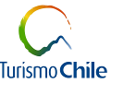  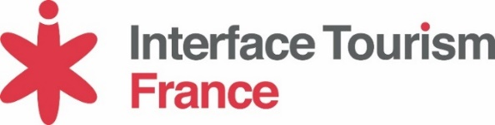 | 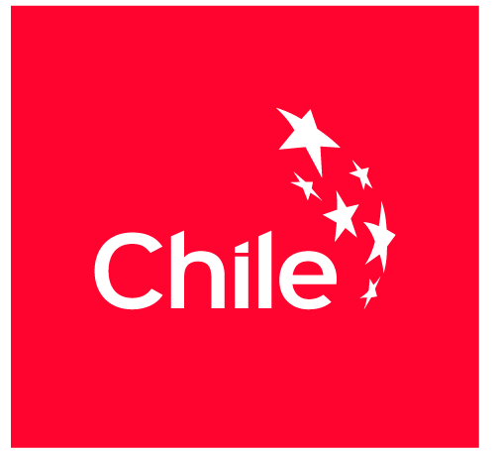  Press Release  Paris, June 14th 2016
Interface Tourism mandated again to represent the Chilean Tourism Board on the French market!

Paris, June 14th 2016 – Following a RFP, the Chilean Tourism board has decided to reiterate their trust in Interface Tourism agency to ensure its promotion activities on the French market.
For the 2016-2017 year, Interface Tourism & Turismo Chile will implement a broad communication plan to the B2C, trade activities, and with the press.
The objectives are to increase awareness of the destination and to establish its position as a South America must-see destination.
France remains one of the priority markets for Chile which still wishes to attract new visitors targets (niche tourism: astronomy, oenology, gastronomy... etc.)

Contact Interface Tourism France
Cécile Lacroute
chili@interfacetourism.com
01.53.25.03.54

